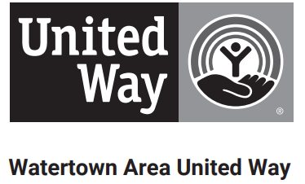
2025-2026 ALLOCATION APPLICATION CHECKLIST

The items below are needed within the online 2025 Allocation Application for 2026 funding.
REQUIRED
Agency Information
Impact Analysis
Client Characteristics
Program Service Statistics
2025 & 2026 Program Budgets
Provide at least one NEW success story on how your organization’s program is assisting people in our community and the surrounding areas. Provide up to 5 photos related to your
Funding Request
Financial Reporting: 2025 & 2026 Program Budget
Letter of Intent
Program’s Board of Directors
Acknowledge Black Out Policy
COUNTERTERRORISM COMPLIANCE
Submit a copy of your IRS determination letter stating you are a 501(c)3 organization if applicable. If you are not a 501(c)(3), please provide an organizational chart or letter explaining what type of organization you are and how it is governed
OPTIONAL
If you believe it would be beneficial to our Board of Directors reviewing your application, upload an optional budget narrative on the last page
Although this checklist is optional, it can assist you in navigating the Allocation Application process for Watertown Area United Way. Please submit your online application by 5:00 p.m. on Wednesday, April 16th, 2025. Late submissions will not be accepted.

Allocation Interviews are scheduled for May 21st and May 22nd. Your specific interview time will be emailed to you in April. Virtual interviews are not available.
Make sure to bring individuals who can provide insight into your program’s operations, financials, and future plans.

Also, ensure that all required documents are uploaded with your online application. If your agency is applying for more than one program, a separate application must be submitted for each program.

ALL APPLICANTS WILL SUBMIT THE GENERAL DOCUMENTS LISTED BELOW.

2025-2026 ALLOCATION APPLICATION FINANCIAL CHECKLIST

DEPENDING ON YOUR TOTAL BUDGET, APPLICANTS WILL SUBMIT THE FINANCIAL DOCUMENTS BELOW.
Please see our Financial Accountability Requirements for Partner Agencies for more information. Depending on your organization’s total budget you will be required to submit different financial reporting documents. Below are checklists for each level. With questions call or email United Way.

Total Budget $100,000 or more
Copy of your most recent Audit.
Copy of your most recent IRS 990.
Copy of your most recent W-9.
Copy of your most recent Management Letter from audit firm if applicable.

Total Budget under $100,000
Statement from a financial committee or Board Treasurer explain review of financials.
Statement describing the process used to minimize risk of embezzlement, fraud, or financial mismanagement.
Year-end financial statement(s).
Plan to conduct an audit in the future.
Copy of your most recent IRS 990 if applicable.
Copy of your most recent W-9 if applicable.

Total Budget under $25,000
Contact Watertown Area United Way office at (605) 886-5815 or director@wartertownunited.org.

Total Budget over $100,000 but do not conduct audit.
Contact Watertown Area United Way office at (605) 886-5815 or director@wartertownunited.org.

